Initially, I tried to run the simulation environment directly on macOS. However, installing and configuring ROS 2, Gazebo, and Nav2 on a MacBook Air M2 was difficult because of the ARM architecture and compatibility issues. To improve stability and development speed, I installed VMware Fusion Pro and set up an Ubuntu 24.04.4 Desktop ARM64 virtual machine.
After setting up the Ubuntu environment, I installed ROS 2 Jazzy, Gazebo, and Nav2. I first tested the standard ROS 2 Nav2 TurtleBot simulation in Gazebo and RViz to understand how Nav2 performs path planning and obstacle avoidance before applying it to the drone scenario. The TurtleBot demo was useful because it already provides the interfaces expected by Nav2, including odometry, transforms, laser scan data, costmaps, and velocity commands.
In the TurtleBot demo, I initialized the robot position in RViz using “2D Pose Estimate” and then sent navigation goals using “Nav2 Goal.” Nav2 successfully planned paths around obstacles and controlled the robot to reach the selected goals. I also observed that the robot sometimes moved backwards or rotated to avoid obstacles, showing that Nav2 uses its local controller and costmap rather than simply moving directly toward the target.
This confirmed that the Nav2 navigation pipeline works correctly in my Ubuntu VM setup. It also provided a baseline for adapting Nav2 to the drone simulation.

Required Bridges for Applying Nav2 to the Drone Simulation
Nav2 cannot directly control the drones in the current Gazebo setup because the drones are not yet exposed to ROS 2 in the same way as TurtleBot. The current drone simulation is mainly controlled through Gazebo topics and Python scripts, while Nav2 expects ROS 2 topics and coordinate frames.
To apply Nav2 to the drones, several bridges are required. First, Nav2 publishes velocity commands on /cmd_vel using geometry_msgs/msg/Twist. These commands must be converted into the Gazebo command topic used by the drone. Second, Nav2 needs odometry and transform information, so the drone pose from Gazebo must be converted into /odom and /tf. Third, Nav2 needs obstacle information, either from a static map, a simulated sensor such as lidar, or directly published obstacle positions.
For the first prototype, I simplified the problem by using only one drone at a fixed altitude. In this setup, Nav2 can be treated as a two-dimensional planner in the horizontal x-y plane, while the drone maintains a constant height.
The intended integration pipeline is:
Gazebo drone pose → ROS 2 /odom and /tf → Nav2 localization and planning
Nav2 /cmd_vel → ROS-Gazebo bridge → Gazebo drone velocity command → drone movement

First Bridge Between ROS 2 and the Gazebo Drone
To begin the integration, I created a new SDF world containing one X3 UAV, a ground plane, and one static obstacle. Using one drone instead of the previous three-drone collision scenario made the first Nav2 integration easier to debug.
The drone model was loaded from the locally downloaded Gazebo Fuel model directory, and the X3 UAV multicopter motor and velocity-control plugins were kept in the SDF. The drone was started at a fixed altitude so that the first prototype could focus on horizontal x-y movement.
I first created a Python bridge script to subscribe to ROS 2 /cmd_vel, publish odometry and transform information, and send velocity commands to the drone. However, sending Gazebo commands from Python using repeated gz topic subprocess calls caused timeout warnings and was not reliable for continuous control.
To debug this, I inspected the available Gazebo topics for the drone and found the correct command topics:
/drone_1/enable
/drone_1/gazebo/command/motor_speed
/drone_1/gazebo/command/twist
An earlier attempt used /model/drone_1/gazebo/command/twist, but this was not the topic used by the drone controller. After identifying the correct topic, I tested direct Gazebo control by publishing gz.msgs.Twist messages to /drone_1/gazebo/command/twist. The drone moved successfully, confirming that the Gazebo-side controller was working.
Next, I replaced the subprocess-based command method with ros_gz_bridge. This bridge converted ROS 2 geometry_msgs/msg/Twist messages from /cmd_vel into Gazebo gz.msgs.Twist messages on /drone_1/gazebo/command/twist. After enabling the drone and publishing ROS 2 /cmd_vel commands, the drone moved successfully in Gazebo.
This completed the first bridge required for Nav2-drone integration:
ROS 2 /cmd_vel → ros_gz_bridge → Gazebo /drone_1/gazebo/command/twist → drone movement
This established the command side of the Nav2-drone interface.

Second Bridge: Gazebo Drone Pose to ROS 2 Odometry and TF
After completing the first bridge from ROS 2 /cmd_vel to the Gazebo drone velocity command topic, I implemented the second required bridge in the opposite direction. The goal of this bridge was to publish the drone’s simulated pose from Gazebo into ROS 2 as /odom and /tf, so that Nav2 can later know where the drone is located.
For this step, I used Gazebo’s world pose information topic. Initially, I tested /world/drone_nav2_world/pose/info, but this topic contained pose information for several entities in the world, including the ground plane, obstacle, sun, and drone. I then switched to /world/drone_nav2_world/dynamic_pose/info, which is more suitable because it focuses on dynamic entities such as the drone.
The Gazebo dynamic pose topic was bridged into ROS 2 using ros_gz_bridge and remapped to /gz_pose. I then created a Python node called drone_pose_to_odom_tf.py. This node subscribes to /gz_pose, extracts the drone pose, and continuously publishes:
/odom
odom -> base_link transform
map -> odom static transform
During testing, the bridged Gazebo pose messages did not preserve clear frame names, so the script could not directly identify a frame named drone_1. To solve this, the Python node was modified to select the most suitable dynamic transform and publish it as the drone pose. Since the current test world contains only one drone, this was sufficient for the single-drone prototype.
After running the dynamic pose bridge and the Python odometry/TF bridge, the /odom topic appeared correctly in ROS 2, and tf2_echo confirmed that the odom -> base_link transform was being published. When the drone was moved using ROS 2 /cmd_vel, the odometry values changed accordingly. For example, the x-position increased from approximately 0.0 to values such as 0.27, 1.97, and 3.26, confirming that the ROS 2 odometry was tracking the drone movement.
This completed the second required bridge:
Gazebo drone pose → ros_gz_bridge → ROS 2 /gz_pose → Python node → /odom and /tf
At this point, the drone simulation has both basic interfaces needed for future Nav2 integration:
ROS 2 /cmd_vel → Gazebo drone movement
Gazebo drone pose → ROS 2 /odom and /tf
This is an important checkpoint because Nav2 requires both command output and feedback input. The attached log shows that /odom is being published correctly and that the ROS 2–Gazebo bridge is working. The next step is to use these two bridges together and test whether Nav2 can send velocity commands to the drone based on its estimated position.
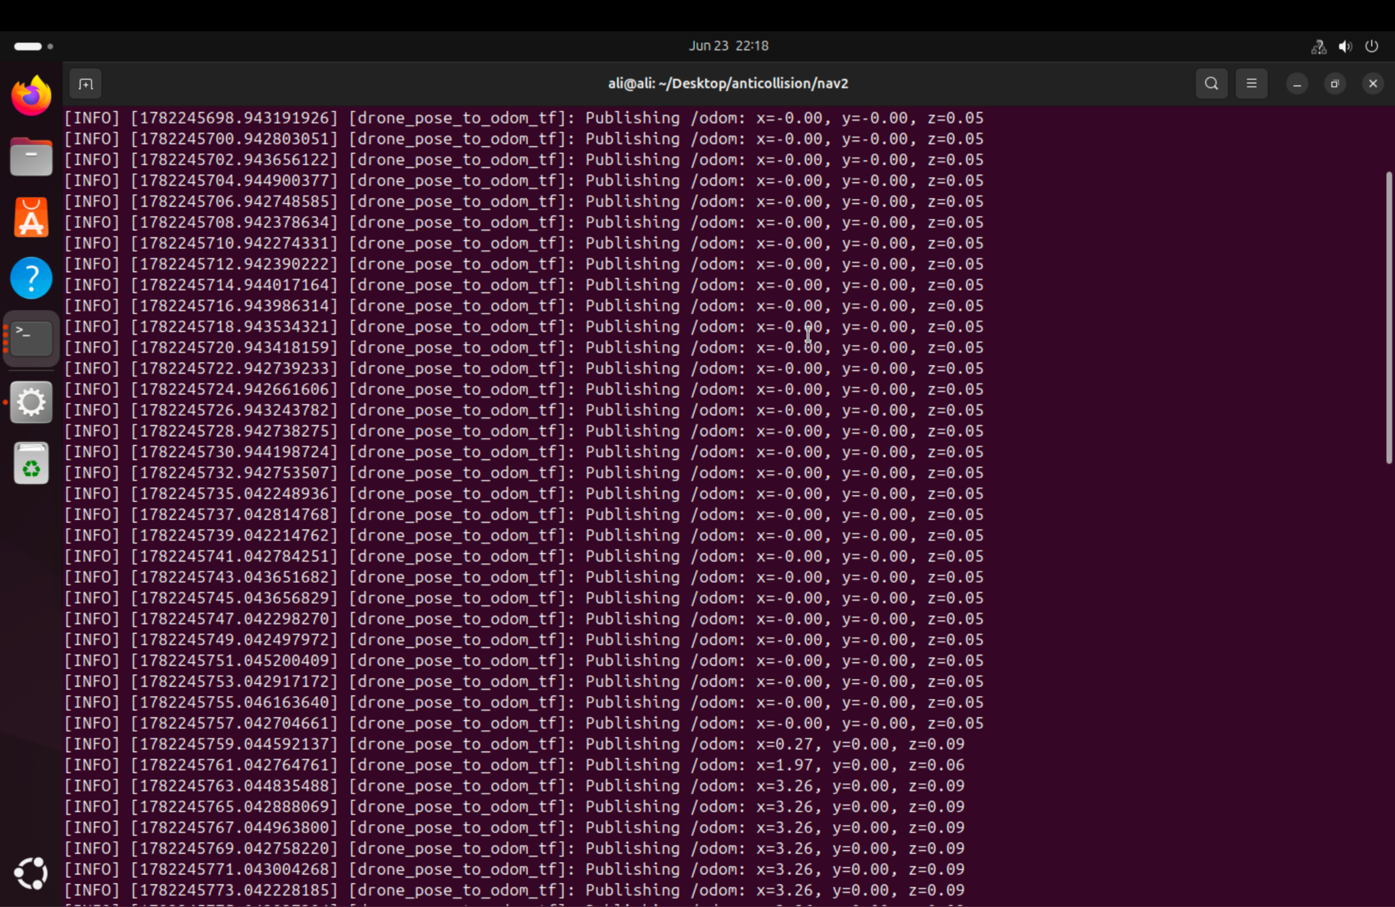

Combined Bridge Test and Automation
After confirming the command bridge and the feedback bridge separately, I tested both bridges together. In this setup, ROS 2 velocity commands are sent to the drone through the /cmd_vel bridge, while the drone pose is simultaneously published back to ROS 2 through /odom and /tf.
To make the testing process easier and more repeatable, I created shell scripts to start and stop the bridge stack automatically. The startup script launches the Gazebo drone world, the Gazebo dynamic pose bridge, the Python odometry/TF bridge, the ROS 2 /cmd_vel to Gazebo command bridge, and the drone enable command. I also created a separate movement test script that publishes a forward /cmd_vel command for a few seconds and then sends zero velocity commands to stop the drone.
This automation reduces the number of manual terminal commands needed for each test and makes the setup more reliable for repeated experiments. After running the automated stack, the drone moved successfully in Gazebo, and the /odom values updated during the movement. This confirmed that the command and feedback bridges can operate together correctly.
The completed automated bridge pipeline is:
start_drone_stack.sh → launches Gazebo and all required bridges
test_move_drone.sh → publishes /cmd_vel and verifies drone movement
stop_drone_stack.sh → stops the Gazebo and bridge processes
This step is important because it prepares the system for the next phase, where Nav2 will replace the manual movement test script and generate /cmd_vel commands based on navigation goals.

Third Bridge: Obstacle Sensing for Nav2
With the command and odometry bridges working, the last missing input was obstacle information. Nav2 builds its costmaps from sensor data; without any sensor the costmap stays empty and Nav2 plans straight through obstacles. I first added a gpu_lidar sensor to the drone in the SDF world, together with the Gazebo sensors system plugin, and bridged the scan topic into ROS 2 as /scan.
The sensor registered correctly and its topic appeared in the Gazebo topic list, but no scan messages were ever published, even when echoing the topic directly on the Gazebo side. The cause is that rendering-based sensors such as gpu_lidar compute their ranges on the GPU and need a working OpenGL context. The VMware virtual machine cannot provide a stable one: without 3D acceleration Gazebo reports “No 3D enabled”, and with 3D acceleration enabled the virtual GPU driver is too unstable for Gazebo’s render engine — the GUI hangs and the sensor still publishes nothing.
Since obstacle information may also come from directly published obstacle positions, I replaced the GPU lidar with a virtual lidar node, virtual_lidar.py. It subscribes to /odom, casts 360 rays from the drone’s pose against the known obstacle rectangles, and publishes a standard sensor_msgs/LaserScan on /scan at 10 Hz. From Nav2’s perspective the result is indistinguishable from a simulated lidar, and it requires no rendering at all. The obstacle list is kept in sync with the world file, and on a machine with a working GPU the real gpu_lidar can be swapped back in.

Improved Odometry, Simulation Time, and Cleanup
I replaced the height-based frame selection workaround in the odometry bridge. The drone model now carries Gazebo’s OdometryPublisher plugin, which publishes the drone’s true pose and velocity on its own named topic /model/drone_1/odometry. The Python bridge simply subscribes to that topic and republishes /odom and the odom -> base_link transform, so there is no more guessing which entity in a pose stream is the drone, and the velocity comes from the simulator instead of finite differences.
I also bridged Gazebo’s /clock into ROS 2 and enabled use_sim_time on all nodes, so scans, odometry, transforms, and Nav2 share a single simulation clock. The earlier dead-reckoning prototype bridge was archived into an old/ folder, and all terminals and test runs now write their output into a logs/ folder, which proved essential for debugging the failures described below.

Nav2 Configuration and First Obstacle Avoidance Runs
Nav2 is configured mapless: there is no static map and no AMCL; map -> odom is a static identity transform and both costmaps are filled purely from /scan through an obstacle layer and an inflation layer. The DWB controller is configured as holonomic (non-zero lateral velocity limits) so the planner can use the drone’s ability to move sideways. The standard Jazzy nav2_bringup launch file turned out to start additional servers (collision monitor, route server, docking server) that fail without their own configuration, so I wrote a minimal launch file that starts only the controller, planner, behavior server, and BT navigator with a lifecycle manager.
The test scenario is a 1×4×2 m wall at x = 4 and a goal at (8, 0), so a straight-line path would pass through the obstacle. The first run succeeded in about 20 seconds with no recovery behaviors. The return flight to (0, 0), however, aborted after three minutes and 17 recovery behaviors. The recorded logs showed that the drone had actually reached a position 0.24 m from the goal within 20 seconds — inside the position tolerance — but arrived facing away from the requested final heading. Rotating in place produces no translation, so Nav2’s progress checker repeatedly declared “failed to make progress” and eventually gave up.
The fix follows from the platform: a quadcopter’s final heading is irrelevant because it can translate in any direction regardless of where it faces. I disabled the yaw goal tolerance and removed the rotate-to-goal critic from the controller. After this change, repeated back-and-forth runs completed 3 out of 3 with SUCCEEDED, 18–19 seconds per 8 m leg, zero recovery behaviors, and a ratio of distance traveled to Euclidean distance of approximately 1.3 — the effectiveness metric suggested for the evaluation, computed directly from the recorded goal logs.

Visualization and Portability
For visual inspection I added two independent viewers that attach to the running simulation. view.sh opens RViz with a preconfigured display: the odometry trail (the actually flown path), the lidar points tracing the wall, the global costmap with its inflation band, and the planned path around the obstacle; goals can also be sent by clicking in the view. view_gazebo.sh attaches Gazebo’s own 3D window to the headless server. In the virtual machine the Gazebo GUI only works with 3D acceleration disabled (software rendering is slow but stable, while the accelerated virtual GPU driver makes the GUI hang); on machines with a real GPU it works normally.
I also removed the remaining portability problems: the world file now loads the X3 model through its Gazebo Fuel URI (downloaded automatically on first run) instead of a local absolute path, all scripts locate their own directory instead of assuming a hardcoded one, and the repository README documents the requirements and the step-by-step run and visualization procedure. The project now runs unchanged on other machines.

Next Steps: Randomized Evaluation
The next phase implements the agreed testing protocol. First, a scenario generator will choose a random start point, a random goal point, and a growing number of randomly placed fixed obstacles, emitting both the world file and the obstacle list from a single source so they cannot disagree. Second, instead of stopping on contact, a collision monitor will count the number of hits during each flight. Third, a batch runner will execute many generated scenarios and aggregate success rate, navigation time, path ratio, and hit count as a function of the number of obstacles. After that, the same harness will be extended to moving obstacles at increasing speeds to identify the point where Nav2’s performance deteriorates significantly, which motivates the additional avoidance component to be added on top of Nav2.

Phase A Implemented: Random Scenarios and Hit Counting
The first part of the testing protocol is now implemented. gen_scenario.py generates a random scenario from two arguments (--n-obstacles and --seed, optionally --out): it picks a random start point, a random goal point at least 8 m away, and N randomly placed box obstacles with obstacle-free zones around start and goal, no overlaps, and heights that always intersect the flight altitude. Crucially, it writes both the Gazebo world (world.sdf, with the drone spawned at the random start) and a machine-readable scenario.yaml from the same data, so the simulation, the virtual lidar, and the collision counter can never disagree about where the obstacles are. The same seed always reproduces the identical scenario.
Collision counting follows the protocol: the run is not stopped on contact. A new node, hit_monitor.py, models the drone as a 0.3 m disc and counts each contact episode with an obstacle, while also tracking the minimum clearance over the whole flight. Its totals are continuously written to logs/hits_current.yaml. The start script accepts a scenario directory (./start_drone_stack.sh scenarios/s42_n4) and passes the scenario to the lidar and the monitor; ./send_nav2_goal.sh --scenario <dir> sends the scenario’s own goal.

Debugging: the Drone That Refused to Move Sideways
The first randomized runs failed in an instructive way. The default world (goal straight ahead) kept working, but scenario goals aborted with repeated “failed to make progress” errors while the drone sat still. Capturing /cmd_vel and the Gazebo command topic during a failing run showed that Nav2 was producing healthy velocity commands and that they arrived in Gazebo unchanged — the drone simply did not respond to them.
Replaying Nav2’s exact command by hand isolated the cause: any command containing a sustained yaw rate (for example angular z of −1.0) stalls the X3’s velocity controller completely, producing no thrust at all, while pure translation commands work. This became the third heading-related Nav2 default that had to be disabled for a multicopter: after removing the final yaw tolerance and the path/goal alignment critics, the controller now also samples no rotation at all (max_vel_theta: 0.0). The drone keeps its spawn heading forever and moves by strafing — which a quadcopter can do freely. A second smaller fix: the motor arming command is now sent by the goal script itself immediately before each goal, closing a race where the arming could fire while Gazebo was still loading a heavier world.
With these fixes both verification scenarios succeed: 4 obstacles with a 12 m sideways-dominant path (SUCCEEDED in 32 s, zero recoveries, zero hits, minimum clearance 2.09 m) and a 10-obstacle stress scenario (SUCCEEDED in 18 s, zero recoveries, zero hits, minimum clearance 0.59 m — the drone threading between obstacle clusters with the inflation layer as its effective safety margin).

How to Run (Current Procedure)
Each numbered step runs in its own terminal from the nav2/ folder:
./gen_scenario.py --n-obstacles 4 --seed 42 — generate a scenario (→ scenarios/s42_n4/)
./start_drone_stack.sh scenarios/s42_n4 — Gazebo (headless) + bridges + virtual lidar + hit monitor; wait until the odometry terminal prints Publishing /odom lines (omit the argument for the classic single-wall world)
./launch_nav2.sh — start Nav2; wait for “Managed nodes are active”
./view.sh — optional RViz view: costmap, planned path, lidar points, odometry trail (goals can also be sent by clicking with the 2D Goal Pose tool)
./view_gazebo.sh — optional Gazebo 3D window attached to the running simulation (in the VM this requires 3D acceleration disabled; on real GPUs it works normally)
./send_nav2_goal.sh --scenario scenarios/s42_n4 — arms the drone and sends the scenario goal; ./send_nav2_goal.sh X Y sends an explicit goal instead
cat logs/hits_current.yaml — hits and minimum clearance of the run; the full feedback stream of every goal is kept in logs/goal_<time>.txt
./stop_drone_stack.sh — teardown (stop Nav2 with Ctrl+C in its terminal)

